2026-06-16_10-29-13.png
Cisco Packet Tracer Step-by-Step Guide
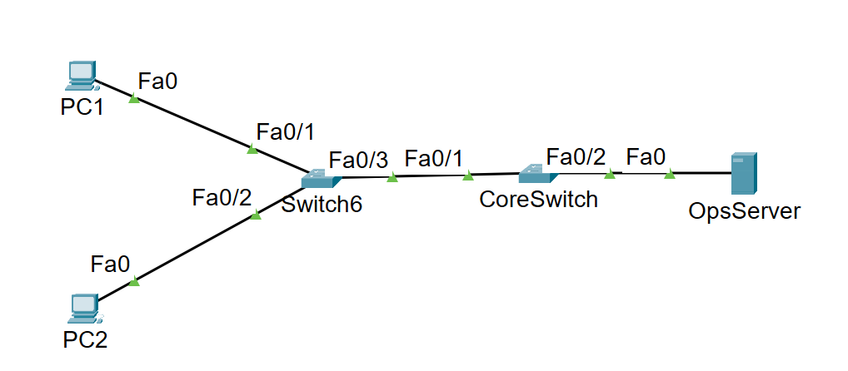
Figure 1. Uploaded topology used for this lab guide.

1. Lab Overview
This guide shows how to recreate the uploaded topology in Cisco Packet Tracer, cable the devices, configure each device, and verify connectivity with ping, traceroute, ARP, routing-table, and MAC address table checks. The design is based on one access switch (Switch6), one core switch (CoreSwitch), two PCs, and one server.

2. Training Objectives
- Stage the endpoints so their Layer 2 identities are easy to spot from the switch.
- Trigger ARP-initiated traffic between PCs on the same VLAN to populate the CAM table.
- Inspect, clear, and repopulate the MAC address table to validate how the switch learns.
- Create the network design, place and cable devices, configure the IP settings, and test connectivity end to end.
- Inspect ARP and routing information so you can explain how traffic moves across the topology.

3. Device Plan
Use these Packet Tracer devices so the topology matches the uploaded image and supports the lab tasks.
Role | Packet Tracer Device | Suggested Name | Notes
PC | PC-PT | PC1 | Connected to Switch6 Fa0/1
PC | PC-PT | PC2 | Connected to Switch6 Fa0/2
Access switch | 2960 | Switch6 | Learns PC MAC addresses
Core switch | 3560 multilayer switch | CoreSwitch | Acts as default gateway 192.168.1.1
Server | Server-PT | OpsServer | Connected to CoreSwitch Fa0/2

4. Addressing Plan
Device | Interface | IPv4 Address | Mask | Default Gateway
PC1 | Fa0 / eth0 | 192.168.1.50 | 255.255.255.0 | 192.168.1.1
PC2 | Fa0 / eth0 | 192.168.1.51 | 255.255.255.0 | 192.168.1.1
OpsServer | Fa0 | 192.168.1.60 | 255.255.255.0 | 192.168.1.1
CoreSwitch VLAN 10 | SVI | 192.168.1.1 | 255.255.255.0 | N/A
Note: The uploaded drawing does not show a router. In this guide, CoreSwitch is treated as a multilayer switch and provides the default gateway address 192.168.1.1 for the PCs and server.

5. Build the Network Design in Packet Tracer
- Open Cisco Packet Tracer and start a new file.
- Drag two PC-PT devices to the left side of the workspace and rename them PC1 and PC2.
- Drag one 2960 switch to the center-left and rename it Switch6.
- Drag one 3560 multilayer switch to the center-right and rename it CoreSwitch.
- Drag one Server-PT to the right side and rename it OpsServer.
- Arrange the devices to match the uploaded image: PC1 above PC2 on the left, Switch6 in the middle, CoreSwitch to the right of Switch6, and OpsServer on the far right.

6. Cable the Devices
Use Copper Straight-Through cables for all links.
- PC1 Fa0 → Switch6 Fa0/1
- PC2 Fa0 → Switch6 Fa0/2
- Switch6 Fa0/3 → CoreSwitch Fa0/1
- CoreSwitch Fa0/2 → OpsServer Fa0
After cabling, wait for the link lights to turn green. If any port stays amber or down, confirm the cable type and the selected interfaces.

7. Configure the End Devices

PC1
- Open PC1.
- Select Desktop > IP Configuration.
- Set IP Address to 192.168.1.50.
- Set Subnet Mask to 255.255.255.0.
- Set Default Gateway to 192.168.1.1.
If your Packet Tracer PC uses the Linux-style terminal in this lab, verify with:
ifconfig eth0
route -n

PC2
- Open PC2.
- Select Desktop > IP Configuration.
- Set IP Address to 192.168.1.51.
- Set Subnet Mask to 255.255.255.0.
- Set Default Gateway to 192.168.1.1.
Verify with:
ifconfig eth0
route -n

OpsServer
- Open OpsServer.
- Select Desktop > IP Configuration.
- Set IP Address to 192.168.1.60.
- Set Subnet Mask to 255.255.255.0.
- Set Default Gateway to 192.168.1.1.

8. Configure Switch6
Open the CLI tab on Switch6 and enter the following commands.
enable
configure terminal
hostname Switch6
interface range fa0/1 - 3
switchport mode access
no shutdown
exit
interface fa0/1
description PC1
switchport access vlan 10
exit
interface fa0/2
description PC2
switchport access vlan 10
exit
interface fa0/3
description Uplink_to_CoreSwitch
switchport access vlan 10
exit
end
write memory
This keeps Switch6 simple for the lab. Fa0/1 and Fa0/2 connect to the two PCs. Fa0/3 is the uplink toward CoreSwitch.

9. Configure CoreSwitch
Use a 3560 or another multilayer switch model so you can create the gateway address 192.168.1.1 on an SVI.
enable
configure terminal
hostname CoreSwitch
vlan 10
name USER_VLAN
exit
interface fa0/1
description Downlink_to_Switch6
switchport mode access
switchport access vlan 10
no shutdown
exit
interface fa0/2
description OpsServer
switchport mode access
switchport access vlan 10
no shutdown
exit
interface vlan 10
ip address 192.168.1.1 255.255.255.0
no shutdown
exit
ip routing
end
write memory
Because every device in this guide is in VLAN 10, the PCs can reach one another directly at Layer 2. The default gateway on CoreSwitch is still useful for routing-table checks and for future expansion.

10. Verify the Workstations (Task 0 - Prep the Workstations)
Verify the bunker PCs are addressed exactly as shown so any CAM table entries you see later are easy to recognize.
- Open the console for PC1. If your lab image uses the Linux login prompt, sign in with username cisco and password cisco.
- Run ifconfig eth0 and confirm the IPv4 address is 192.168.1.50 with mask 255.255.255.0.
- Run route -n and confirm the default gateway is 192.168.1.1.
- Repeat the same checks on PC2 and confirm it reports 192.168.1.51/24 with the same default gateway.
- Match the ports to the drawing: PC1 uses Switch6 Fa0/1 and PC2 uses Switch6 Fa0/2.
PC1:
ifconfig eth0
route -n
PC2:
ifconfig eth0
route -n

11. Task 1 - Generate the ARP Conversation
Use PC1 to reach PC2 so you can watch the ARP request bloom into the switch CAM table.
- On PC1, open the Command Prompt or Linux shell.
- Check the ARP cache first. It should not yet contain 192.168.1.51.
- Send five pings from PC1 to PC2.
- Run arp -a again and confirm PC2 now appears in the ARP cache.
arp -a
ping -c 5 192.168.1.51
arp -a

12. Task 2 - Inspect the Switch CAM Table
- Open the Switch6 CLI.
- Move from user EXEC to privileged EXEC.
- Display the MAC address table.
- Match the two dynamic endpoint MAC addresses to Fa0/1 and Fa0/2. The uplink to CoreSwitch should appear on Fa0/3.
enable
show mac address-table

13. Task 3 - Flush and Re-Learn Entries
- On Switch6, clear only the dynamic MAC entries.
- Immediately return to PC1 and ping PC2 again so the switch learns the addresses again.
- Run show mac address-table on Switch6 and confirm the dynamic entries repopulate on Fa0/1 and Fa0/2.
Switch6# clear mac address-table dynamic
PC1> ping -c 5 192.168.1.51
Switch6# show mac address-table

14. Test Each Network Connection with Ping
After basic workstation verification, test all major paths in the topology.
Test | Command | Purpose
From PC1 to PC2 | ping -c 5 192.168.1.51 | Verifies same-VLAN host-to-host reachability through Switch6
From PC1 to OpsServer | ping -c 5 192.168.1.60 | Verifies traffic across Switch6 and CoreSwitch to the server
From PC2 to OpsServer | ping -c 5 192.168.1.60 | Confirms both user endpoints can reach the server
From OpsServer to PC1 | ping 192.168.1.50 | Validates reverse connectivity from the server

15. Trace the Route Path
Because PC1 and PC2 are in the same subnet, traffic between them does not need a routed hop. A traceroute between them may show the destination directly or may not provide much detail. You can still use traceroute to understand that the path stays on the local VLAN.
PC1:
tracert 192.168.1.51
tracert 192.168.1.60
Linux-style PCs:
traceroute 192.168.1.51
traceroute 192.168.1.60
Expected result: on a flat VLAN, the trace is very short because there is no separate router hop between the end devices.

16. Inspect ARP and Routing Information

ARP checks on the PCs
arp -a
After the pings, PC1 should show an ARP entry for 192.168.1.51 and usually one for 192.168.1.60 after contacting the server.

Routing checks on the PCs
route -n
Look for the connected 192.168.1.0/24 route and the default route pointing to 192.168.1.1.

Switch verification
Switch6# show mac address-table
CoreSwitch# show vlan brief
CoreSwitch# show ip interface brief
CoreSwitch# show running-config

17. Sample Verification Checklist
- PC1 shows 192.168.1.50/24 and default gateway 192.168.1.1.
- PC2 shows 192.168.1.51/24 and default gateway 192.168.1.1.
- OpsServer shows 192.168.1.60/24 and default gateway 192.168.1.1.
- PC1 can ping PC2 successfully.
- PC1 can ping OpsServer successfully.
- Switch6 shows learned MAC addresses on Fa0/1, Fa0/2, and Fa0/3.
- After clear mac address-table dynamic, the dynamic MAC addresses disappear and then reappear after new traffic.
- ARP entries are visible on the PCs after the ping tests.
- The route table on the PCs contains a connected 192.168.1.0/24 network and a default route to 192.168.1.1.

18. Notes for New Learners
- A switch builds its CAM table by learning the source MAC address of incoming frames.
- ARP happens before the first ping reply when a host needs to learn the destination MAC address.
- Same-subnet traffic between PC1 and PC2 is switched, not routed.
- The CAM table and the MAC address table refer to the same idea in this Packet Tracer lab.
- Clearing the dynamic MAC table does not remove static entries.

19. Completion Check
You are finished when PC1 and PC2 display the correct static IP settings, their ARP caches reveal one another after the test, Switch6 shows distinct CAM table entries on Fa0/1, Fa0/2, and Fa0/3, and clearing then regenerating traffic rebuilds the expected MAC address entries without manual intervention.

